**We use Tweets to analyse public sentiment using Azure & Tableau Public**

Used Azure to get real time tweet data on Covid & Social hashtags, cleanse the data and use Cognitive services to perform Sentiment analysis and get a Sentiment score

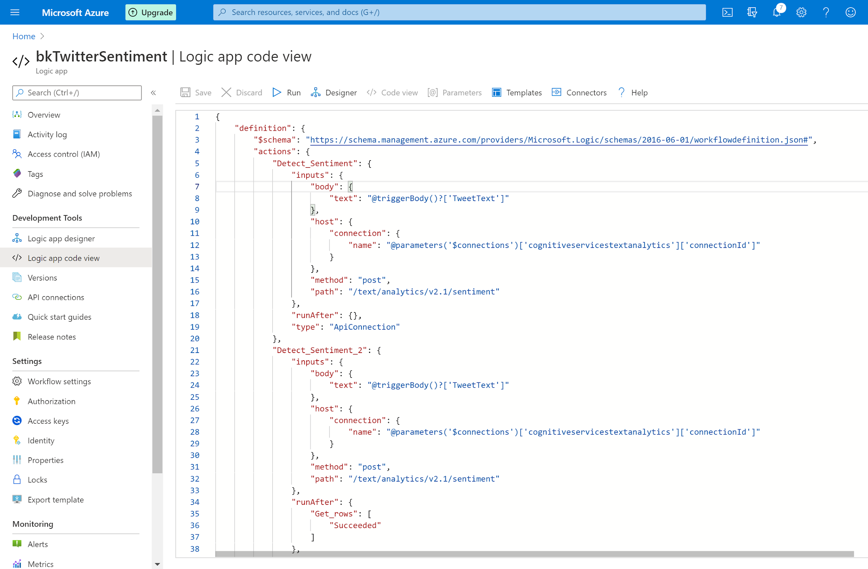

Stored the final output in Google Sheets (near realtime)

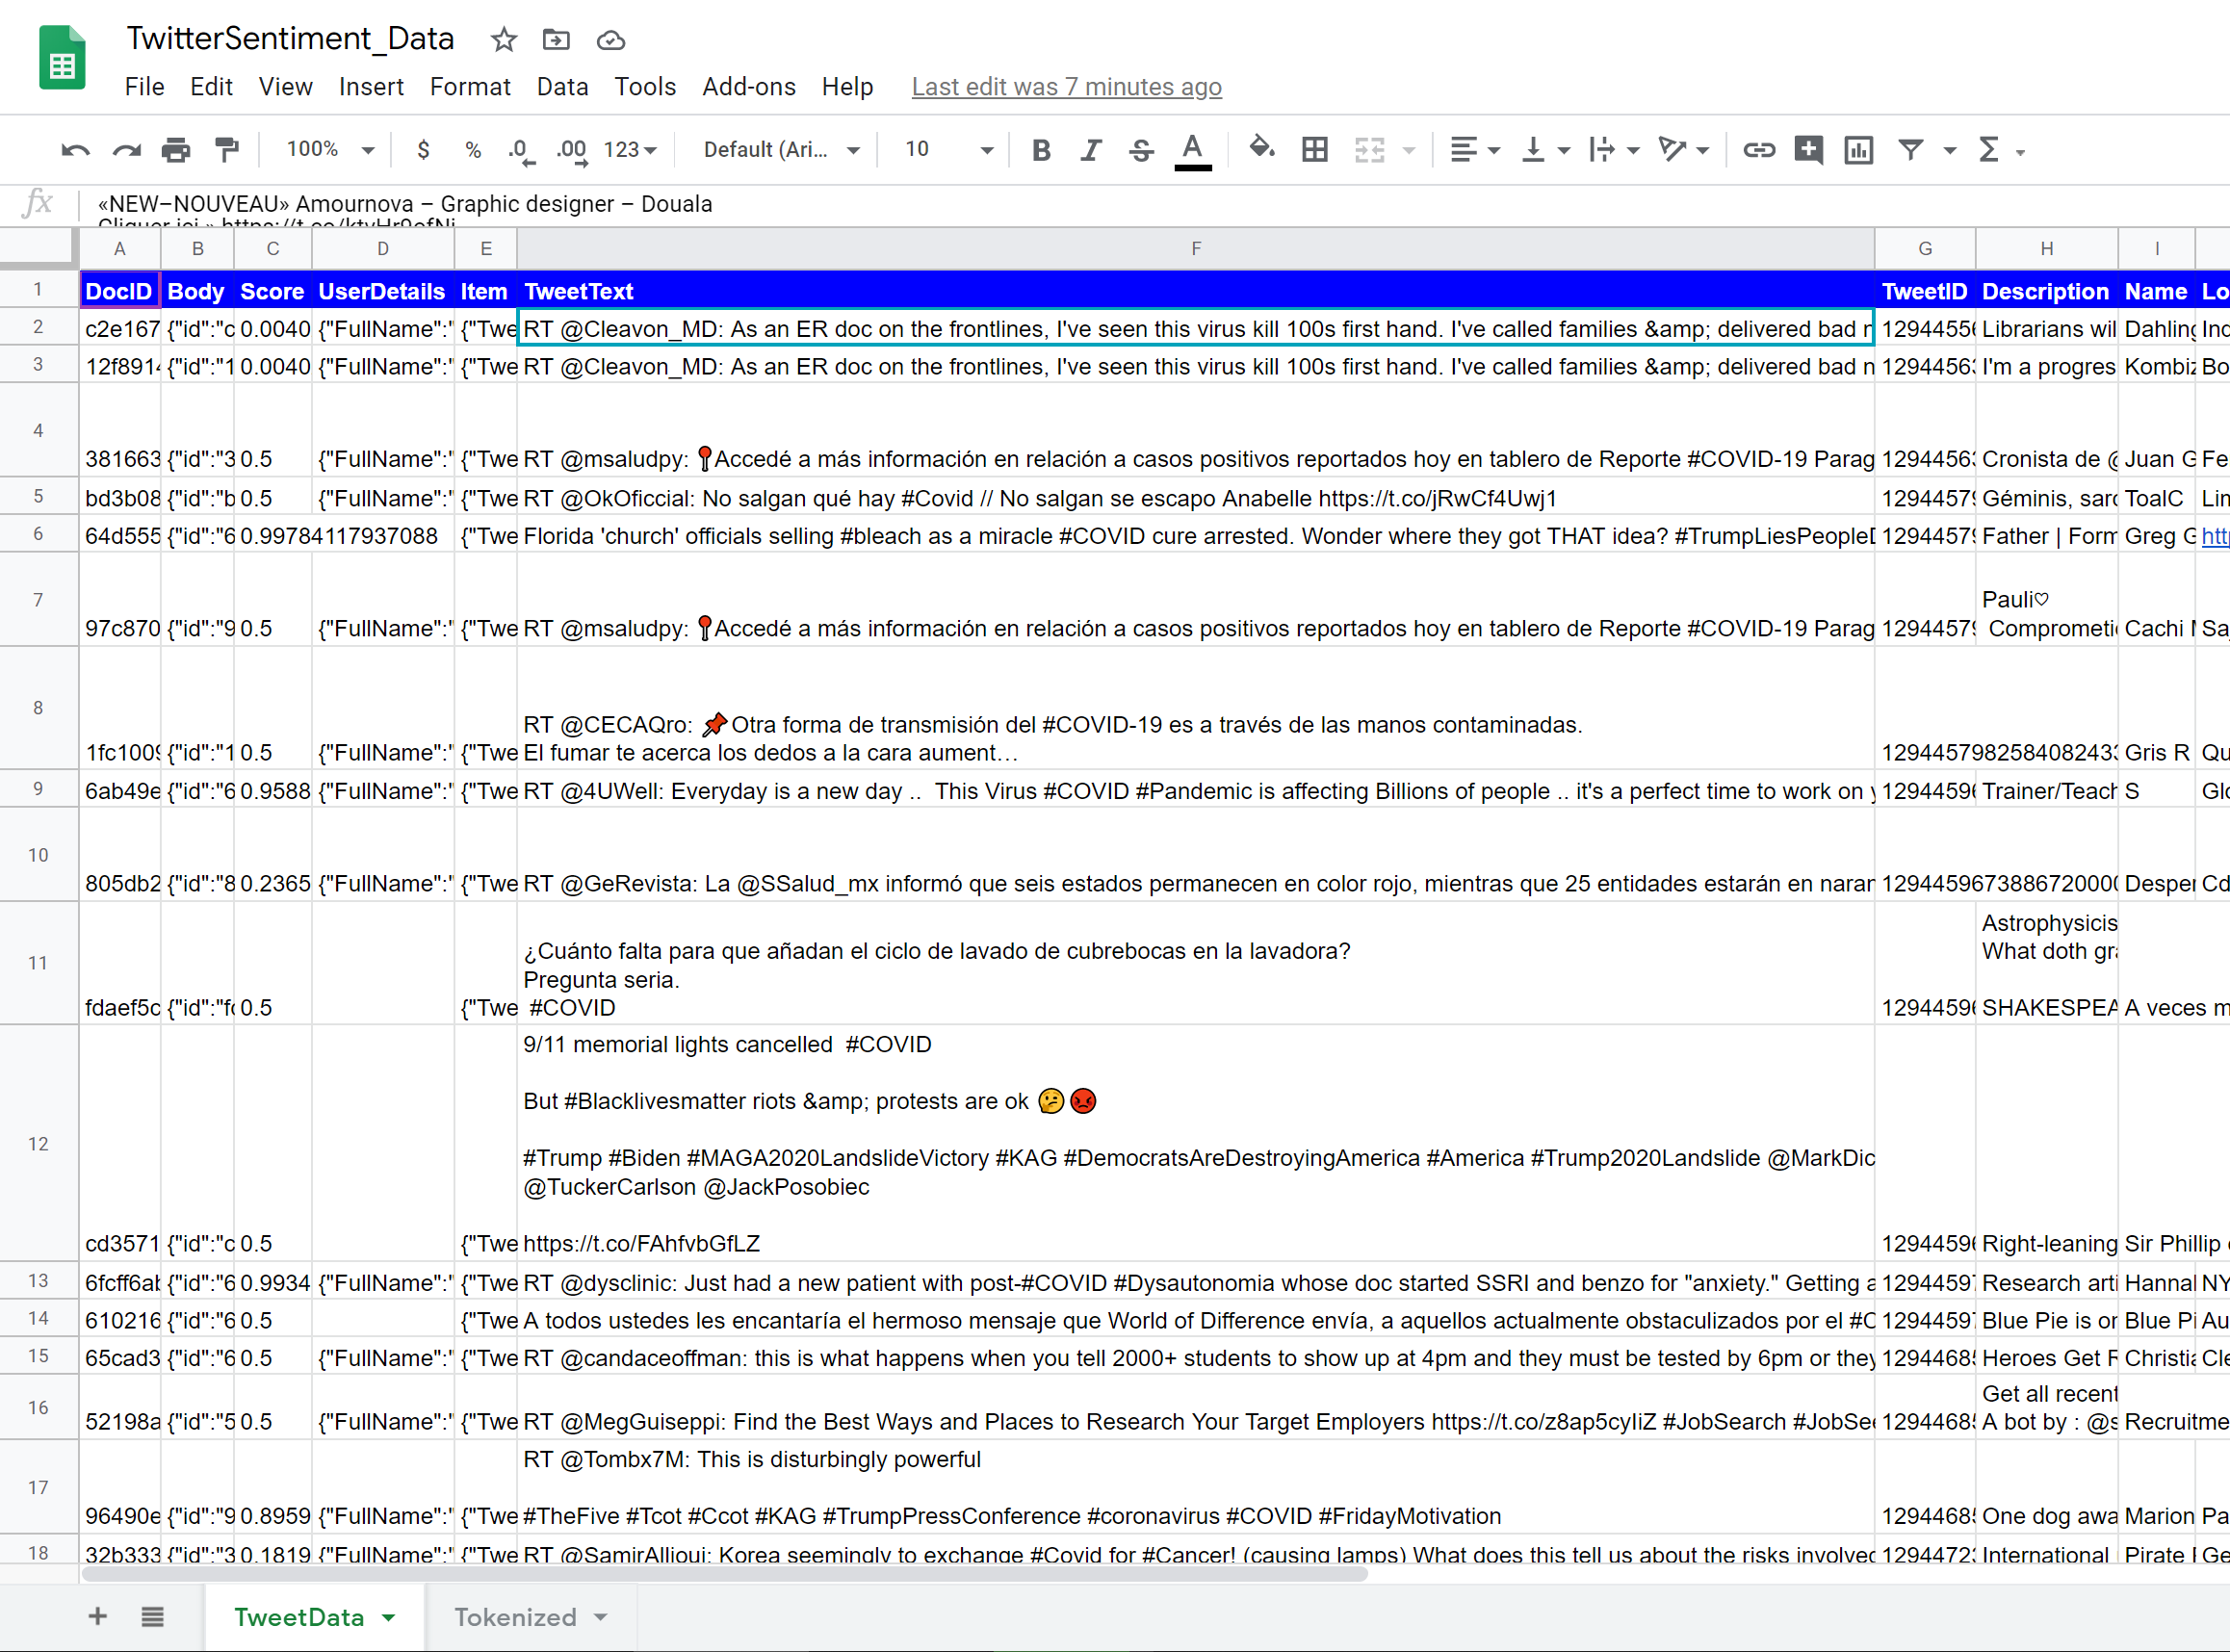

Publish to live dashboard for visual analytics and actionable insights

* + Word cloud of tweets on Covid hashtag

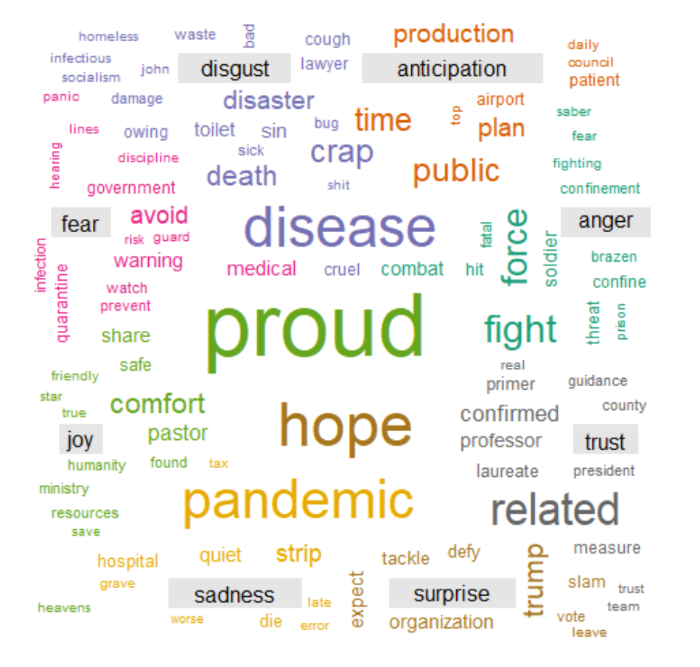

* + Categorized into emotional states

|  |  |  |
| --- | --- | --- |
|  |  | **Tweet Sentiment categorized into emotional states** |
|  |  |  |
| words |  |  |
|  |  |  |
|  |  | n |

Live Tracker

